**SQL QUERIES FOR PIZZA SALES**

**KPI METRICS**

1. **Total Revenue**

Select SUM(total_price) AS Total_Revenue from pizza_sales

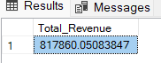

1. **Average Order Values**

SELECT SUM(total_price) / COUNT(distinct order_id) AS Average_Order_Value FROM pizza_sales

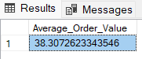

1. **Total Pizzas Sold**

SELECT SUM(quantity) AS Total_Pizza_Sold FROM pizza_sales

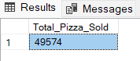

1. **Total Orders**

SELECT COUNT(DISTINCT order_id) AS Total_Order FROM pizza_sales

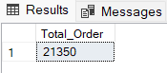

1. **Average Pizzas Per Order**

SELECT CAST(CAST(SUM(quantity) AS DECIMAL(10,2)) /

CAST(COUNT(DISTINCT order_id) AS DECIMAL(10,2)) AS DECIMAL(10,2)) AS Average_Pizzas_Per_Order FROM pizza_sales

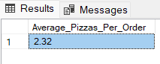

**CHART REQUIREMENTS**

1. **Daily Trend for Total Orders**

SELECT DATENAME(DW, order_date) AS Order_Day, COUNT(DISTINCT order_id) AS Total_Orders

FROM pizza_sales

GROUP BY DATENAME(DW, order_date)

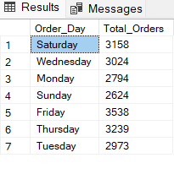

1. **Monthly Trend for Total Orders**

SELECT DATENAME(MONTH, order_date) AS Month_Name, COUNT(DISTINCT order_id) AS Total_Orders

FROM pizza_sales

GROUP BY DATENAME(MONTH, order_date)

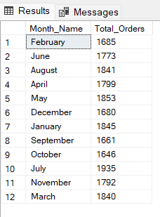

SELECT DATENAME(MONTH, order_date) AS Month_Name, COUNT(DISTINCT order_id) AS Total_Orders

FROM pizza_sales

GROUP BY DATENAME(MONTH, order_date)

ORDER BY Total_Orders DESC

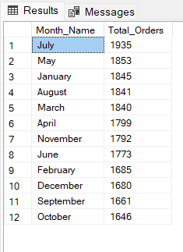

1. **Percentage of Sales by Pizza Category**

SELECT pizza_category, SUM(total_price) * 100 / (SELECT SUM(total_price) from pizza_sales) AS PCT

FROM pizza_sales

GROUP BY pizza_category

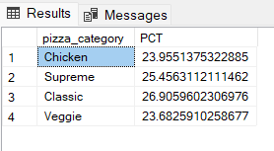

**NOTE:**

**Filters only for Month “July”**

SELECT pizza_category, SUM(total_price) AS Total_Sales, SUM(total_price) * 100 / (SELECT SUM(total_price) from pizza_sales) AS PCT

FROM pizza_sales

WHERE MONTH(order_date) = 7

GROUP BY pizza_category

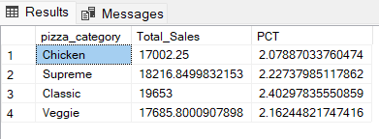

1. **Total Pizzas Sold by Pizza Category**

SELECT pizza_category, SUM(total_price) AS Total_Sales, SUM(total_price) * 100 /

(SELECT SUM(total_price) from pizza_sales WHERE MONTH(order_date) = 7) AS PCT -- Whenever Subquery is used, if Where clause is used it should be applied in Subquery to get correct values

FROM pizza_sales

WHERE MONTH(order_date) = 7

GROUP BY pizza_category

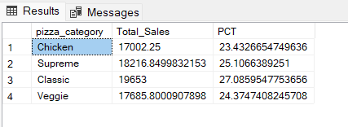

1. **Percentage of Sales by Pizza Size**

SELECT pizza_size, CAST(SUM(total_price) AS DECIMAL(10,2)) AS Total_Sales, CAST(SUM(total_price) * 100 / (SELECT SUM(total_price) from pizza_sales

WHERE DATEPART(QUARTER, order_date) = 1 )

AS DECIMAL(10,2)) AS PCT

FROM pizza_sales

WHERE DATEPART(QUARTER, order_date) = 1

GROUP BY pizza_size

ORDER BY PCT DESC

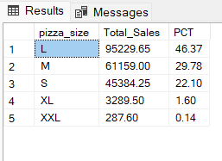

1. **Top 5 Best Sellers by Revenue**

SELECT TOP 5 pizza_name, SUM(total_price) AS Total_Revenue

FROM pizza_sales

GROUP BY pizza_name

ORDER BY Total_Revenue DESC

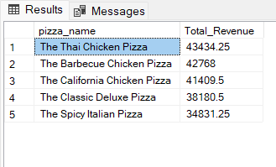

1. **Top 5 Worst Sellers by Revenue**

SELECT TOP 5 pizza_name, SUM(total_price) AS Total_Revenue

FROM pizza_sales

GROUP BY pizza_name

ORDER BY Total_Revenue ASC

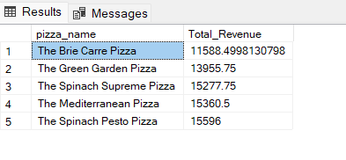

1. **Top 5 Best Sellers by Quantity**

SELECT TOP 5 pizza_name, SUM(quantity) AS Total_Quantity

FROM pizza_sales

GROUP BY pizza_name

ORDER BY Total_Quantity DESC

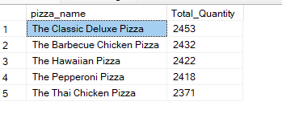

1. **Top 5 Worst Seller by Quantity**

SELECT TOP 5 pizza_name, SUM(quantity) AS Total_Quantity

FROM pizza_sales

GROUP BY pizza_name

ORDER BY Total_Quantity ASC

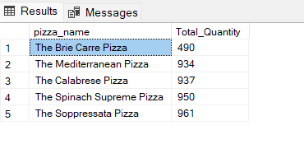

1. **Top 5 Best Sellers by Total Orders**

SELECT TOP 5 pizza_name, COUNT(DISTINCT order_id) AS Total_Orders

FROM pizza_sales

GROUP BY pizza_name

ORDER BY Total_Orders DESC

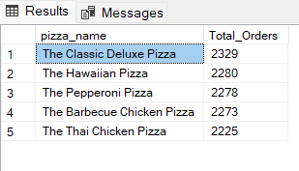

1. **Top 5 Worst Seller by Total Orders**

SELECT TOP 5 pizza_name, COUNT(DISTINCT order_id) AS Total_Orders

FROM pizza_sales

GROUP BY pizza_name

ORDER BY Total_Orders ASC

